Redox Properties of Microwave Irradiation on Spinel Cathode Materials for Lithium-Ion Batteries

Aderemi B. Hardworker*ª, Itumeleng Wisdomª, Mesfin K. Goodman^{b}

ªSchool of Chemistry, University of the Witwatersrand, Wits P O, Johannesburg 2050, South Africa
e-mail: aderemi.hardworker@wits.ac.za
^{b} Energy Research Centre, Council for Scientific and Industrial Research (CSIR), Pretoria 0001, South Africa

Keywords: South African Chemical Society, SACI National Convention, Drug development

Wits MERG and DST Energy Storage Consortium are organising International Symposium on Energy Storage and Industry 4.0 at the KwaMaritane Bush Lodge in Pilannesburg from 31st July to 2nd August 2019. The abstract must strictly be a maximum of one page; make sure to check the grammar and spelling carefully since all mistakes will be faithfully reproduced.

All abstracts must adhere to the following guidelines:
- The font of the body of the abstract must be Times New Roman, size 12
- The line spacing must be single
- Feel free to use figures, schemes, and pictures captioned by a descriptive legend

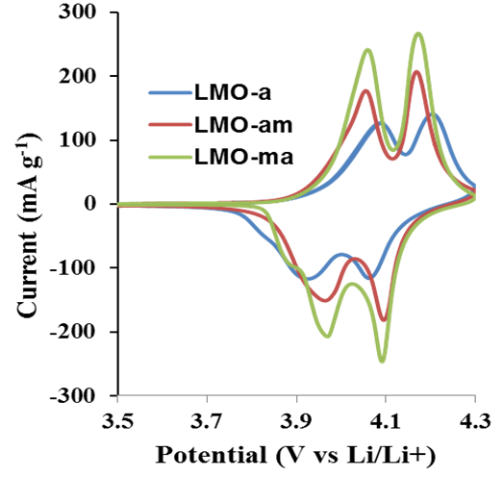

Figure 1 Cyclic voltammograms of lithium manganese oxide (LMO) cathode materials.

REFERENCES: (please use the format shown below)
- Fu, k.; Gong, Y.; Dai, J,; Gong, A.; Han, X.; Yao, Y.; Wang, C.; Wang, Y.; Chen, Y.; Yan, C.; Li, Y.; Wachsman, E.D.; Hu, L. Proc. Natl. Acad. Sci. USA. 2016, 113, 7094.
- Nkosi, F.P.; Jafta, C.J.; Kebede, M.; le Roux, L.; Mathe, M.K..; Ozoemena, K.I.. RSC Adv. 2015, 5, 32256.
- Kebede, M.; Ozoemena, K.I; In Nanomaterials in Advanced Batteries and Supercapacitors, eds. Ozoemena, K.I.; Chen, S.W.; Springer Publishing, New York, 2016; Chap. 1, pp 1-24.

